**select customer_id,account_number,administrator_id,bank_name from account_type where auditor_id='81224'**

->Showing customer id, account number, administrator id, bank name when auditor id is 81224.

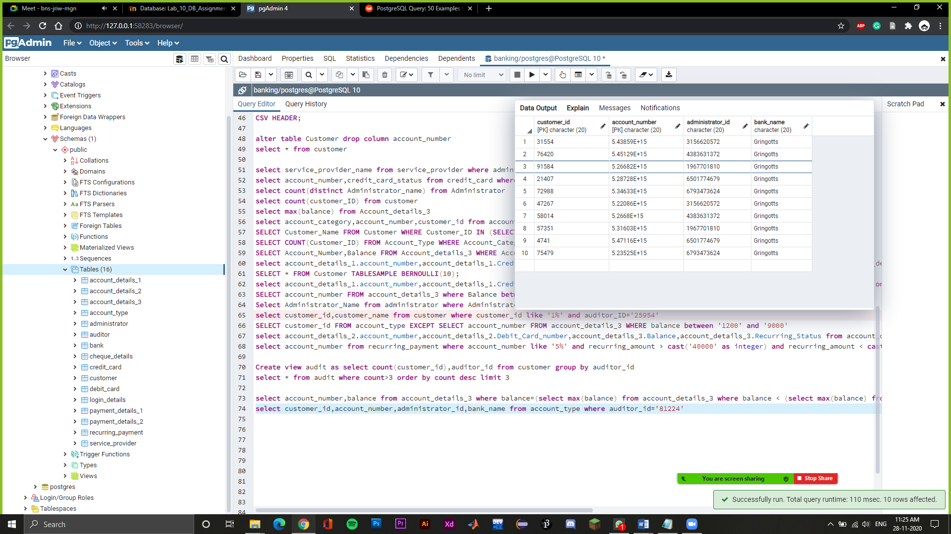

**update customer set customer_name='Lucy' where customer_id='51516';**

->Update customer name as lucy whose customer id is 51516

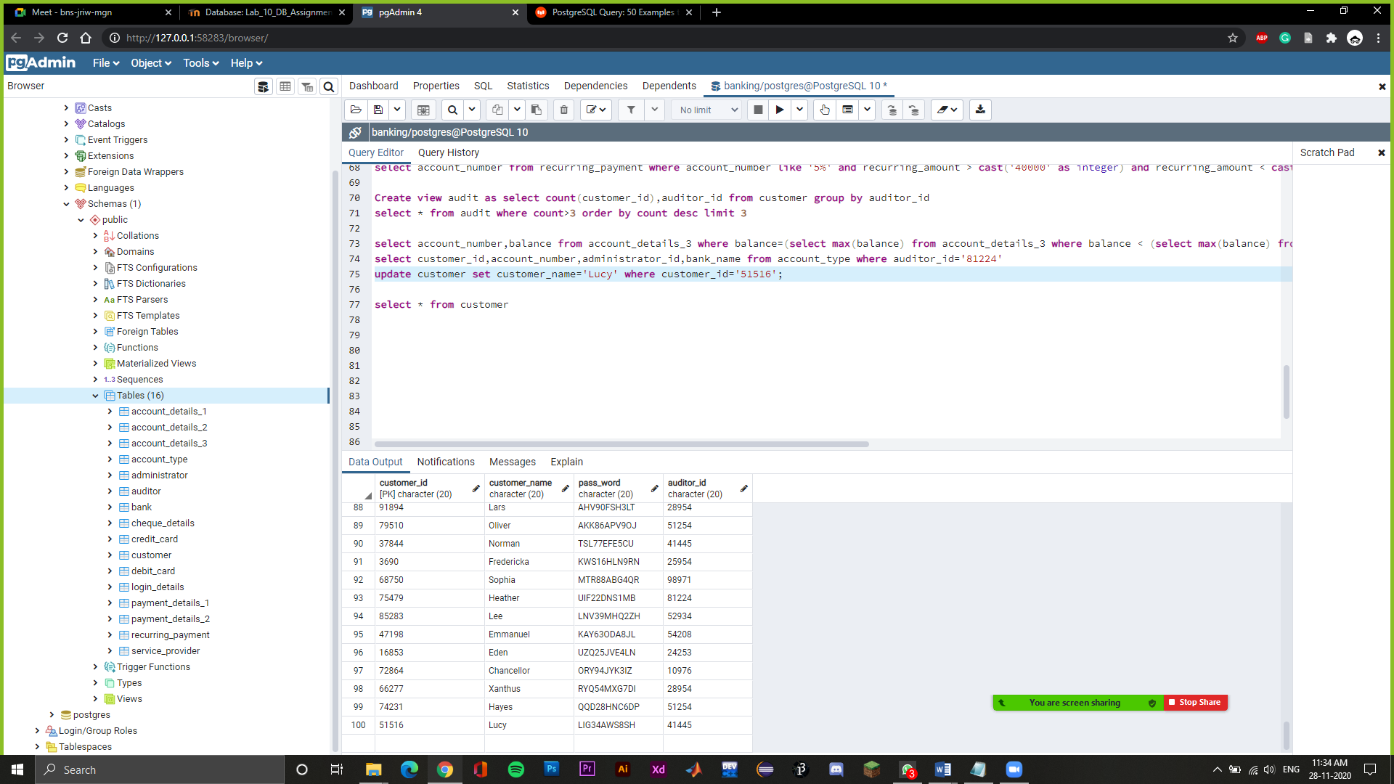

**select account_type.account_category, max(account_details_3.balance) from account_details_3 join account_type on account_details_3.account_number=account_type.account_number group by account_type.account_category**

->Show highest balance of each account category

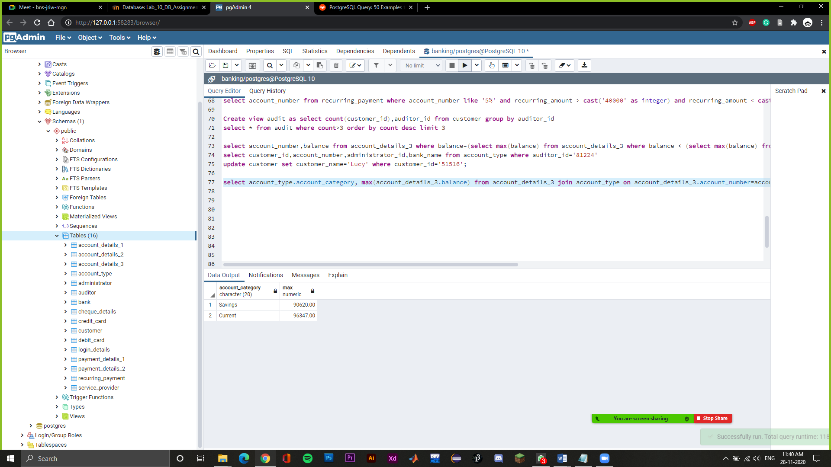

**set statement_timeout=1000;**

**select pg_sleep(2000);**

->Set max query time as 1000 ms

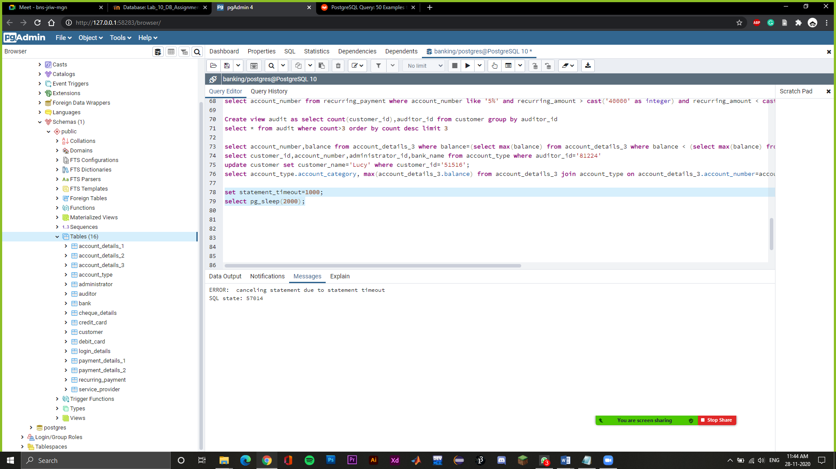

**Create view admin as select count(customer_id),administrator_id from customer join administrator on customer.auditor_id=administrator.auditor_id group by administrator_id**

**select * from admin where count>2**

->Created a view named admin which shows administrator id and count of customer id it serves and below that we have printed down where count is greater than 2.

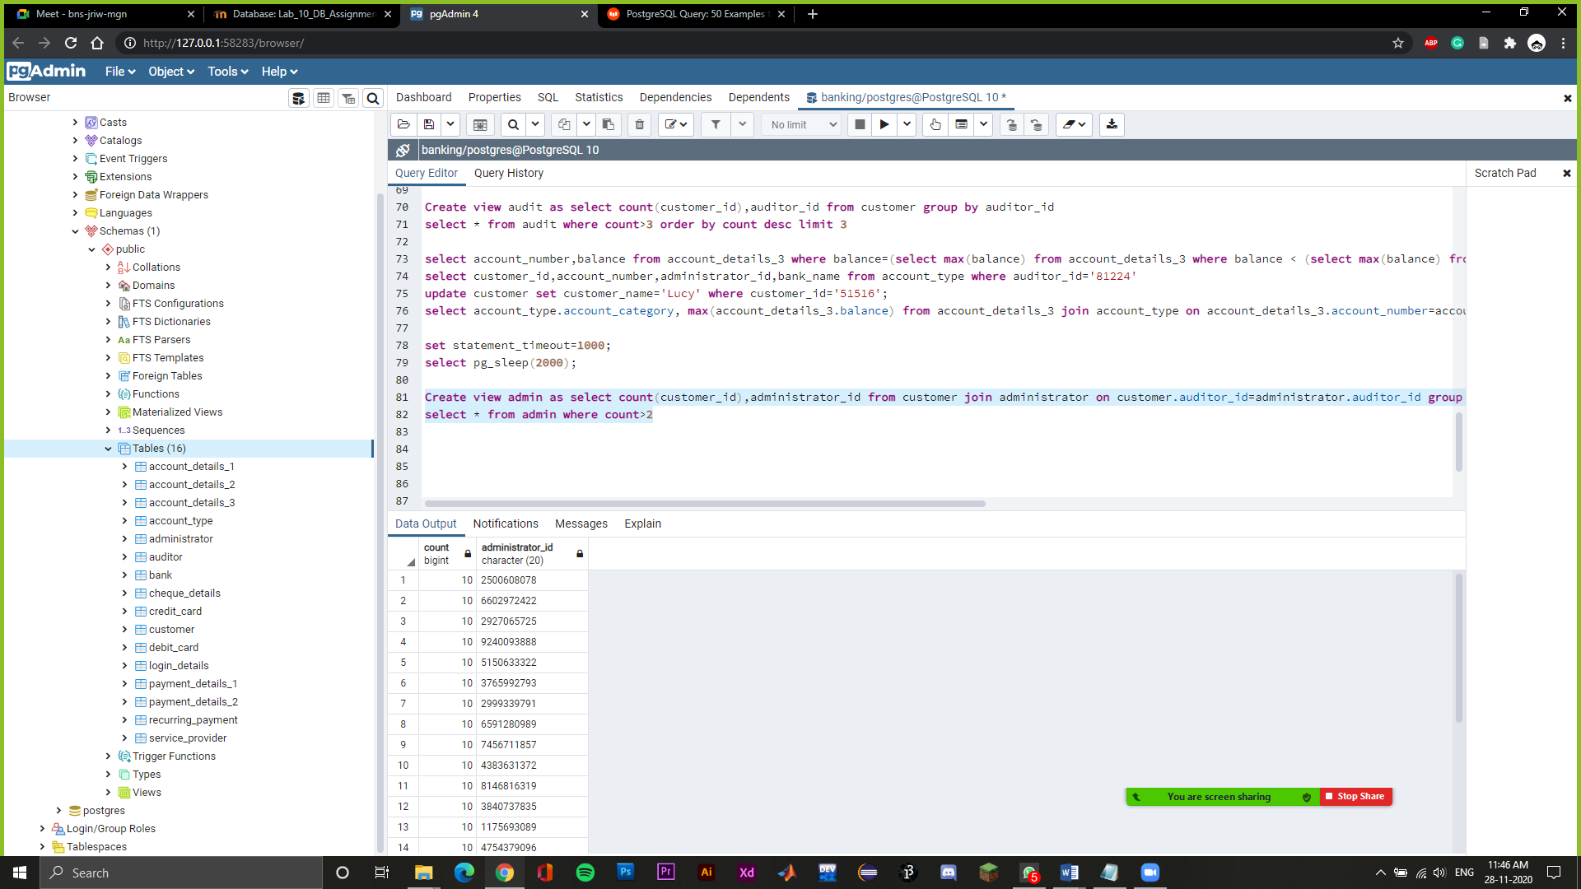

**Select auditor.auditor_id,auditor_name,count(customer_id) from customer join auditor on customer.auditor_id=auditor.auditor_id group by auditor.auditor_id**

->Showing auditor id, auditor name and count of the customer id by performing join operation.

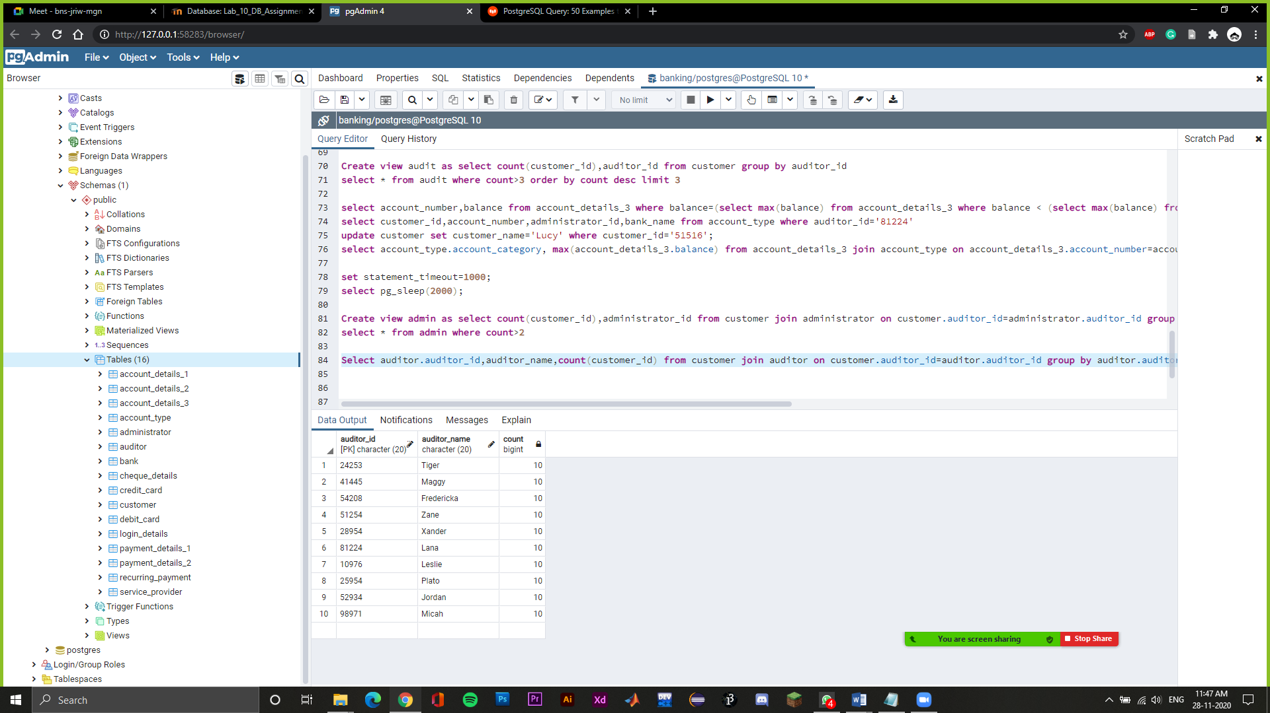

**select service_provider_name, service_provider_id,administrator_id from service_provider where service_provider_id in (select max(service_provider.service_provider_id) from service_provider group by auditor_id)**

->Print service provider name, its ID, corresponding administrator ID where the service provider ID is maximum corresponding to its auditor.

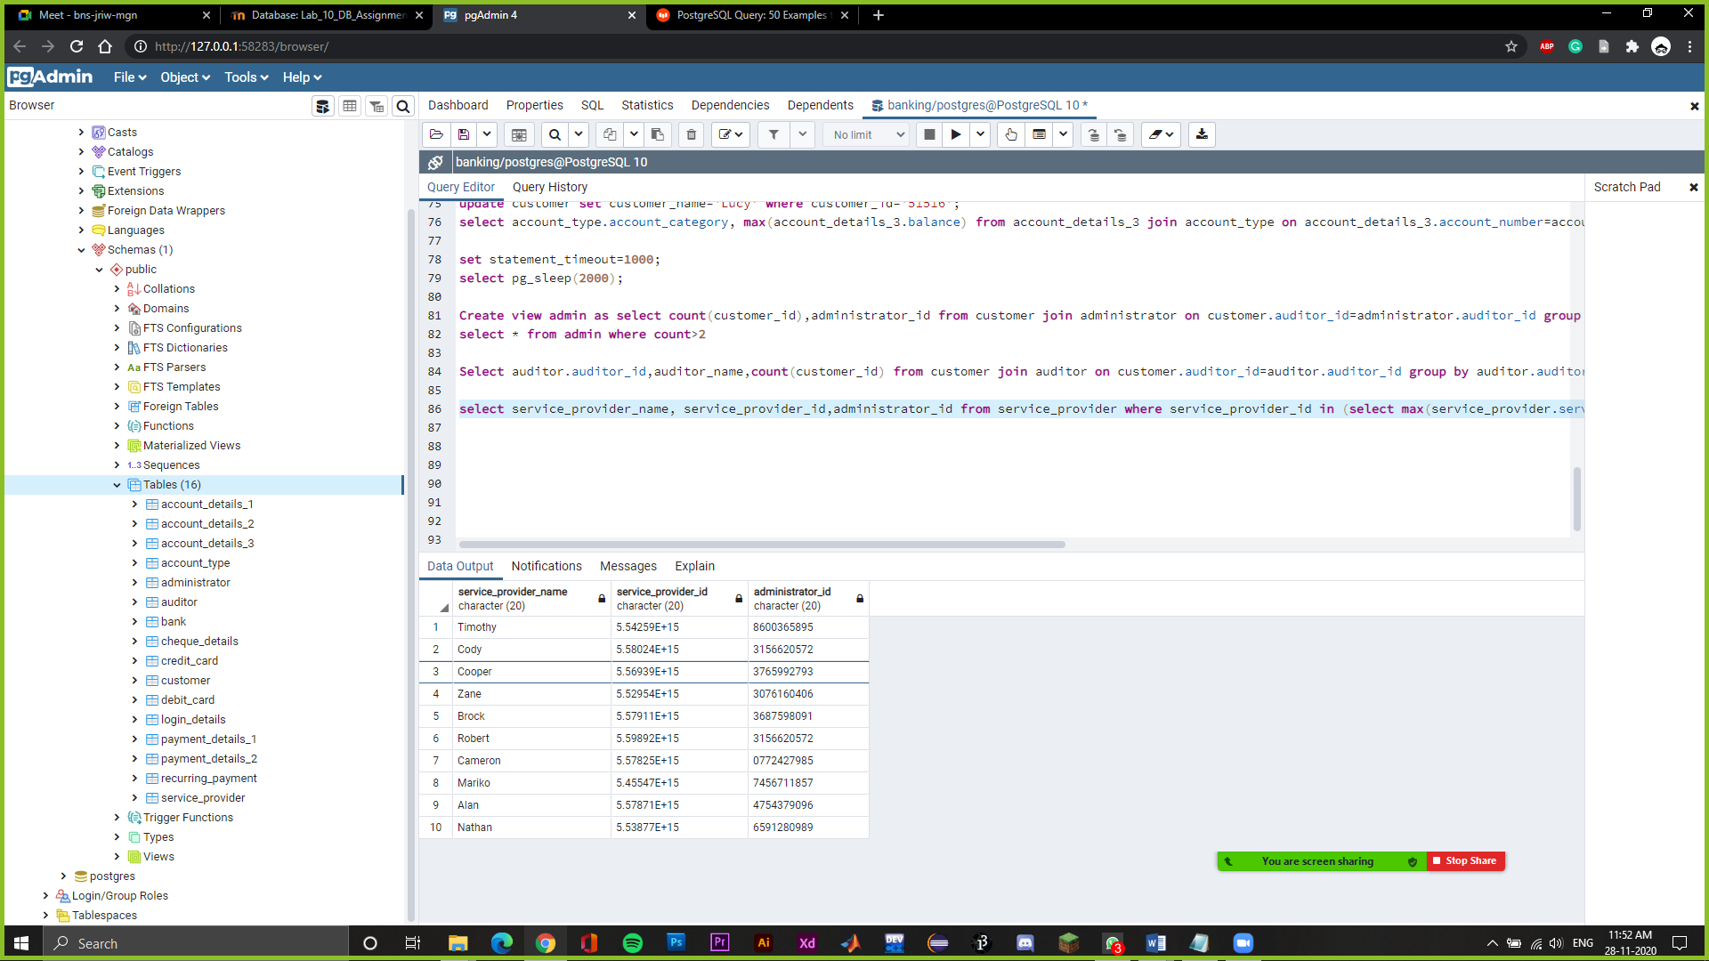

**select customer_id,service_provider_id from service_provider where customer_id in (select max(customer_id) from service_provider group by service_provider_id)**

->Select Maximum Customer ID from the pool of customers who are being serviced by a certain service provider and show the corresponding service provider ID as well

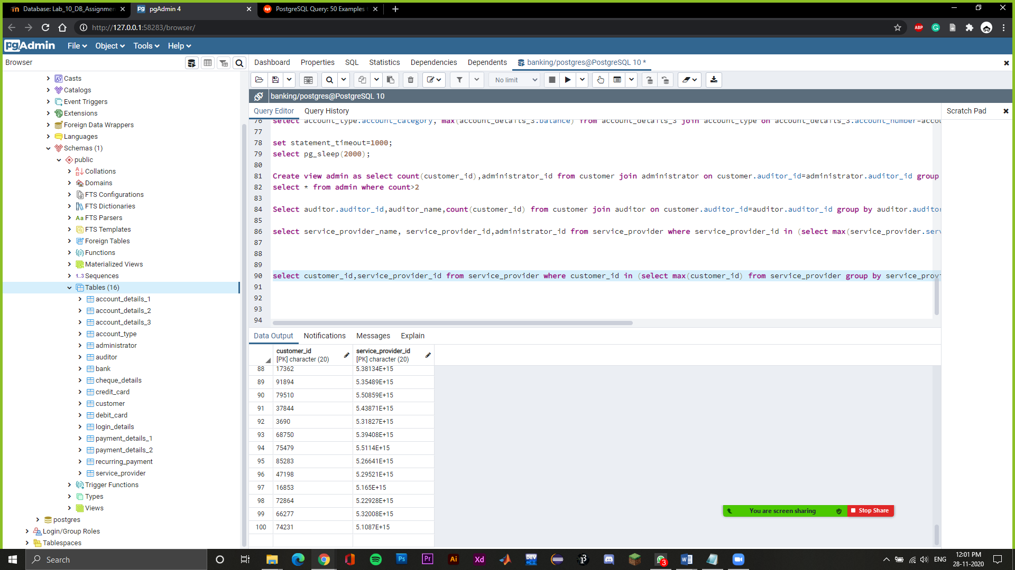

**select administrator_id from admin where count=(select max(count) from admin)**

->Print ID’s of the administrator for those who serve the maximum number of customers.

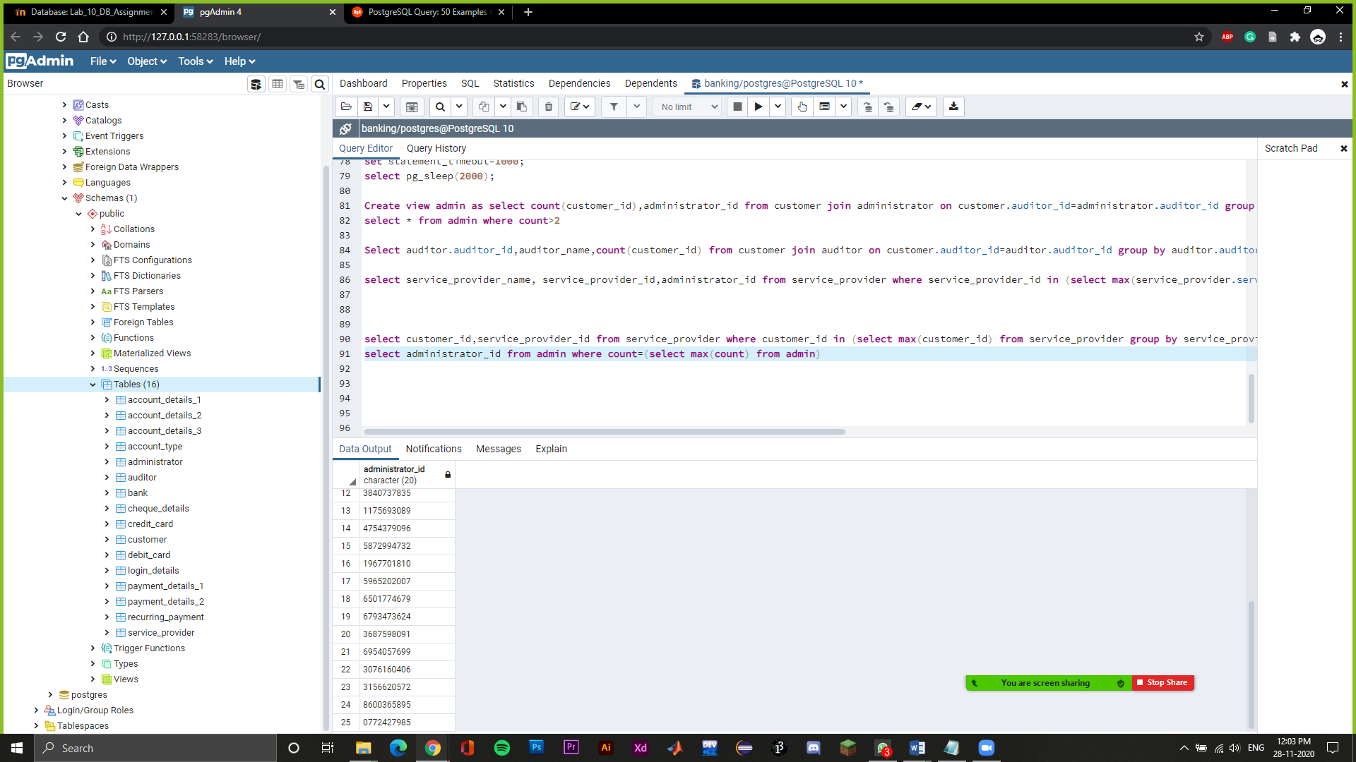

**select * from service_provider where customer_id in (select max(customer_id) from service_provider group by auditor_id)**

->Select maximum Customer ID along with its details corresponding to an Auditor

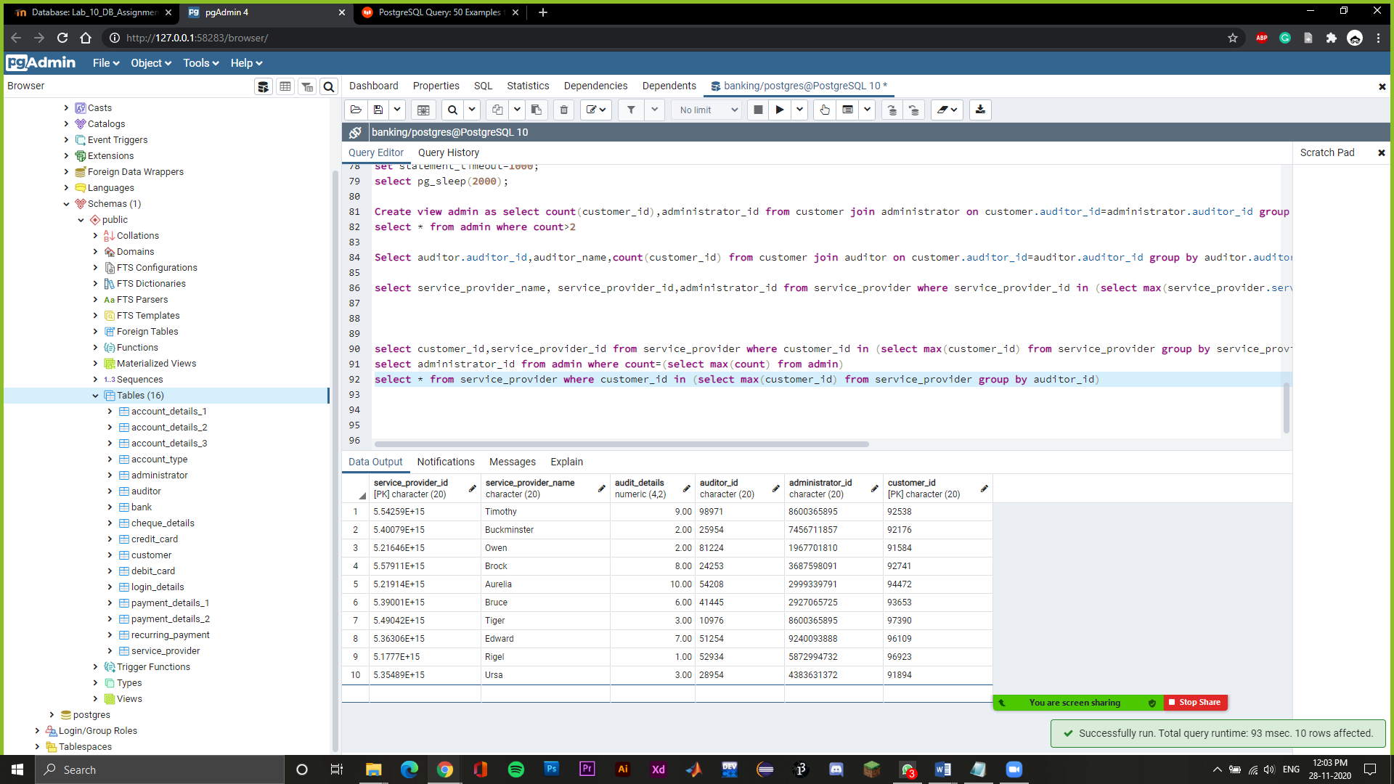

**create view detail as select customer.customer_name,customer.customer_id,account_type.account_number,account_type.account_category,account_type.bank_name from customer join account_type on customer.customer_id=account_type.customer_id**

**select * from detail**

->Create a view which shows all the information of a customer like customer name, customer id, account number, account category and bank name.

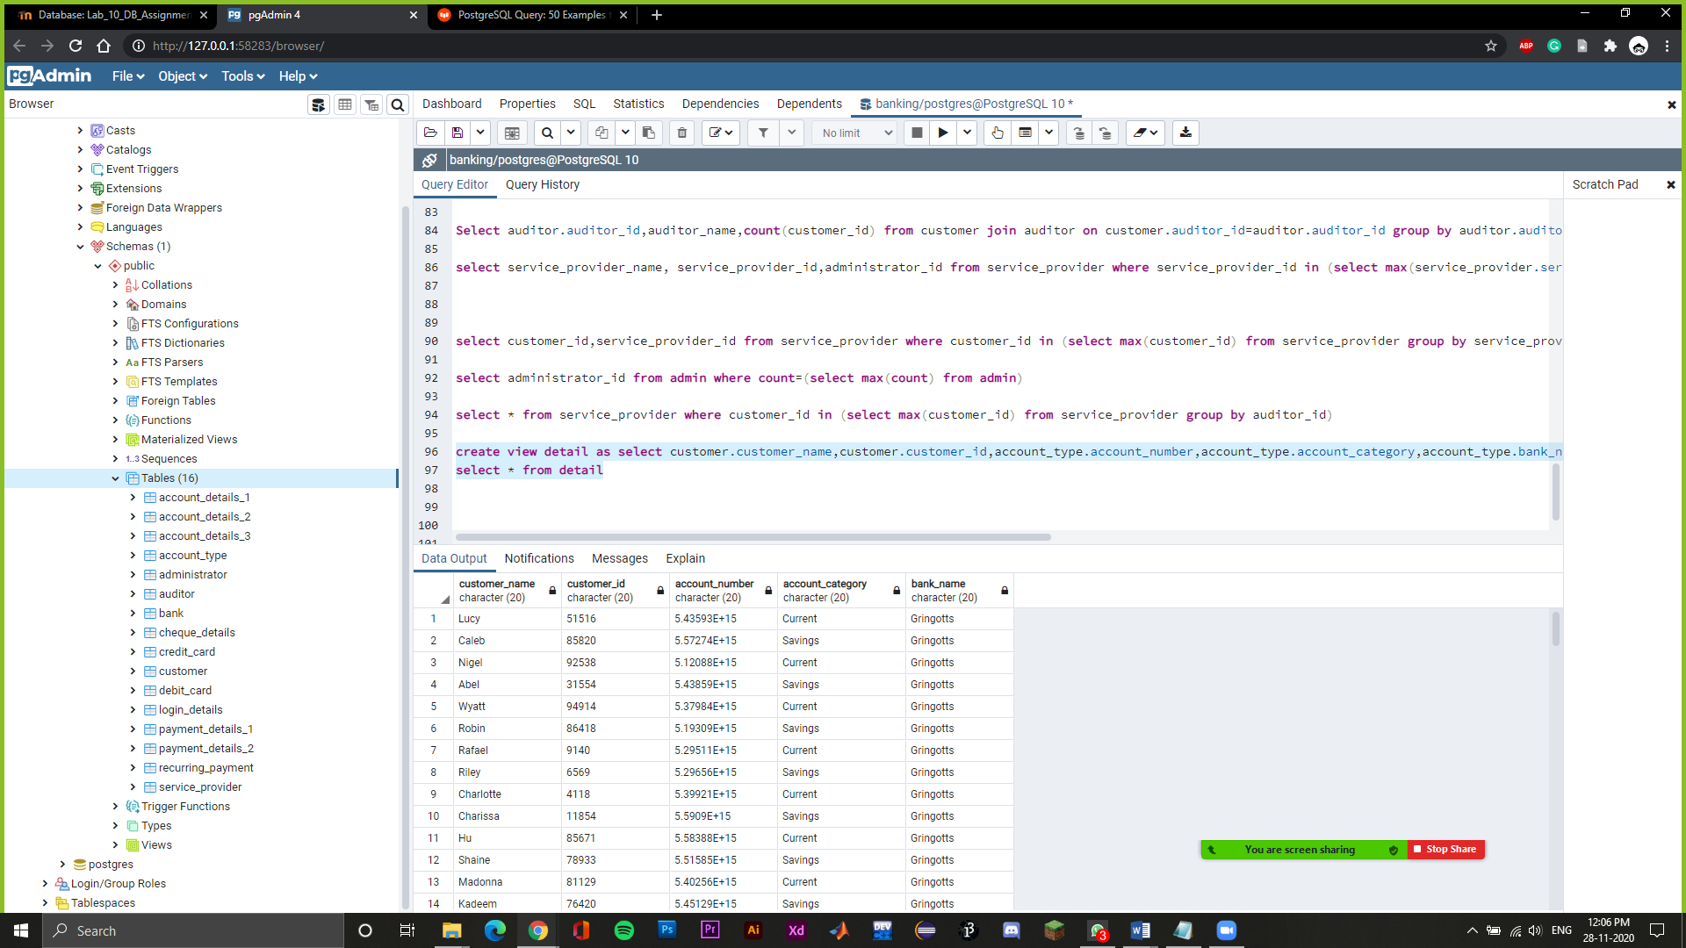

**Select account_details_1.account_number, account_details_1.Credit_Card_number, account_details_2.Debit_Card_number, account_details_3.Balance, account_details_3.Recurring_Status from account_details_1 join account_details_3 on account_details_1.account_number=account_details_3.account_number join account_details_2 on account_details_1.account_number=account_details_2.account_number**

->Join account_details_1,account_details_2 and account_details_3 based on their account number and display their details

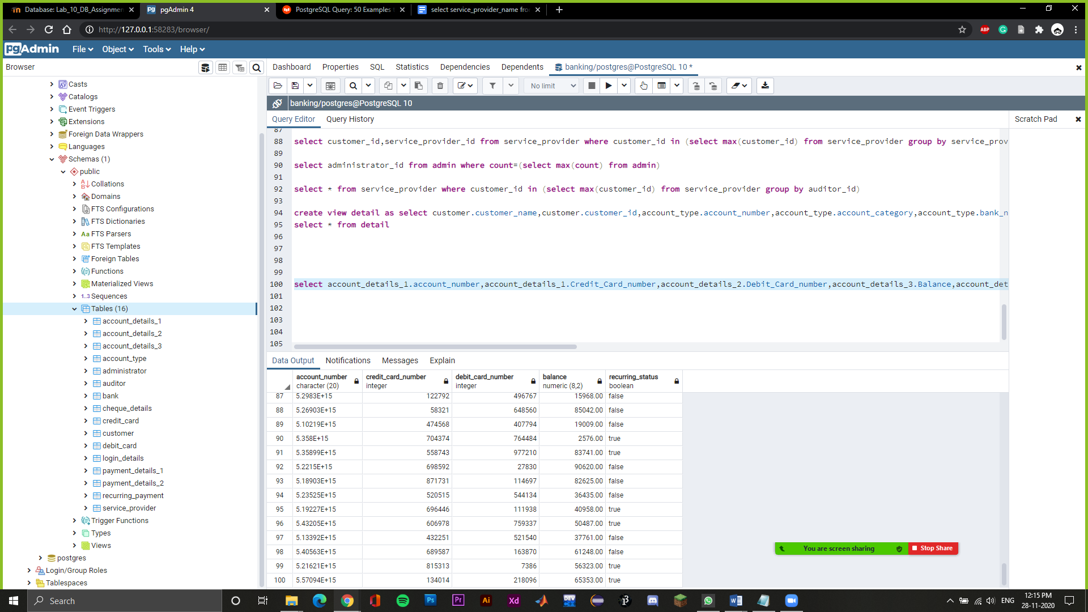

**SELECT customer.customer_name,customer.customer_id FROM customer LEFT JOIN auditor ON customer.auditor_id = auditor.auditor_id;**

->Shows left join of customer name on customer id.

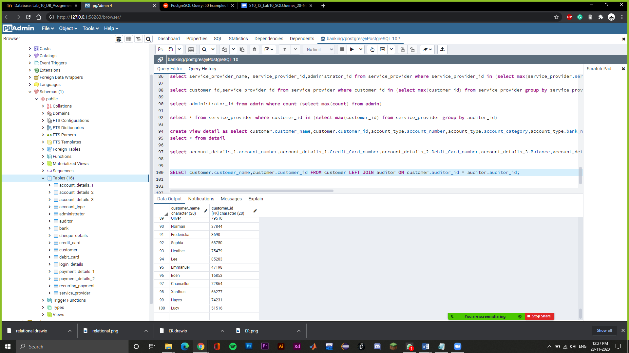

**SELECT administrator.administrator_name,administrator.administrator_id FROM administrator RIGHT JOIN auditor ON administrator.auditor_id = auditor.auditor_id;**

->Shows the right join of administrator name on administrator id.

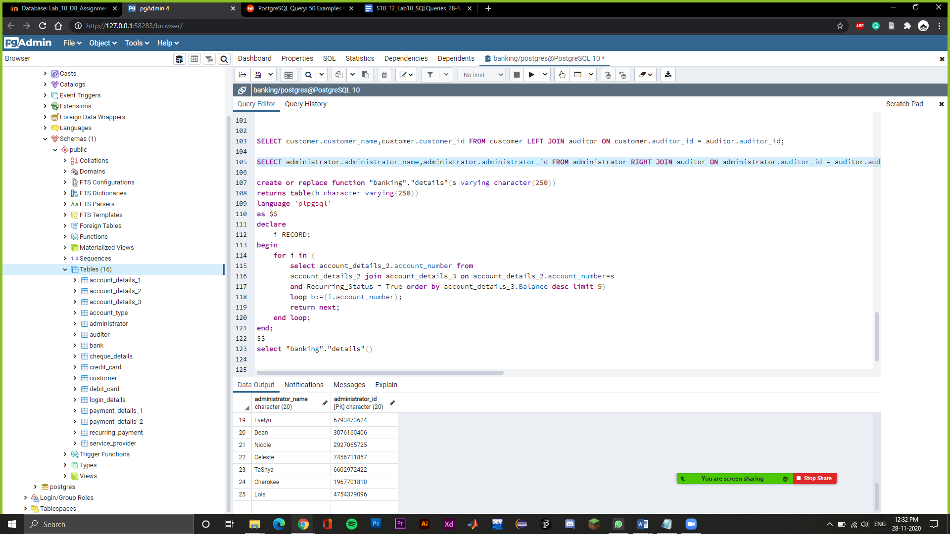

**create or replace function "details"()**

**returns table(b character varying(250))**

**language 'plpgsql'**

**as $$**

**declare**

**i RECORD;**

**begin**

**for i in (**

**select account_details_2.account_number from**

**account_details_2 join account_details_3 on account_details_2.account_number=account_details_3.account_number**

**and Recurring_Status = True order by account_details_3.Balance desc limit 5)**

**loop b:=(i.account_number);**

**return next;**

**end loop;**

**end;**

**$$**

**select "details"();**

->Create a function to display the top 5 account numbers having the highest balance from the join of account_details_2 and account_details_3 where recurring status is true

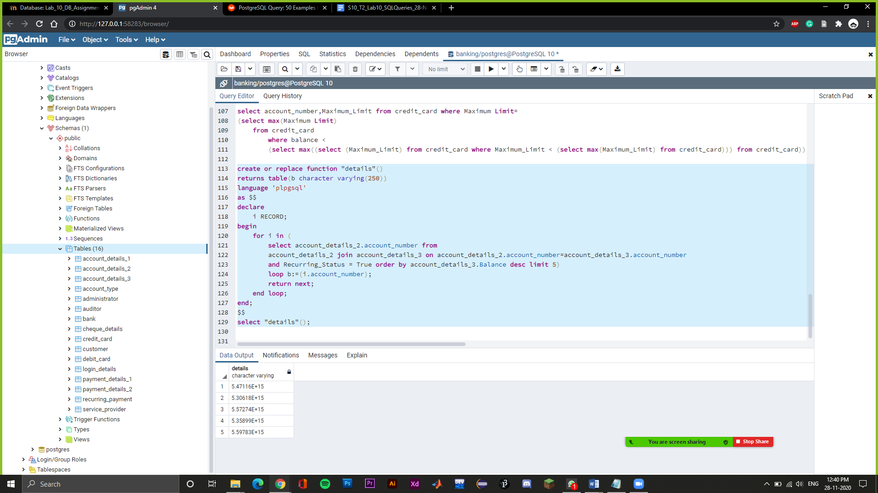

**select account_number,Maximum_Limit from credit_card where Maximum_Limit=**

**(select max(Maximum_Limit) from credit_card where Maximum_Limit < (select max(Maximum_Limit) from credit_card))**

->Select the account number with the second highest Credit Limit

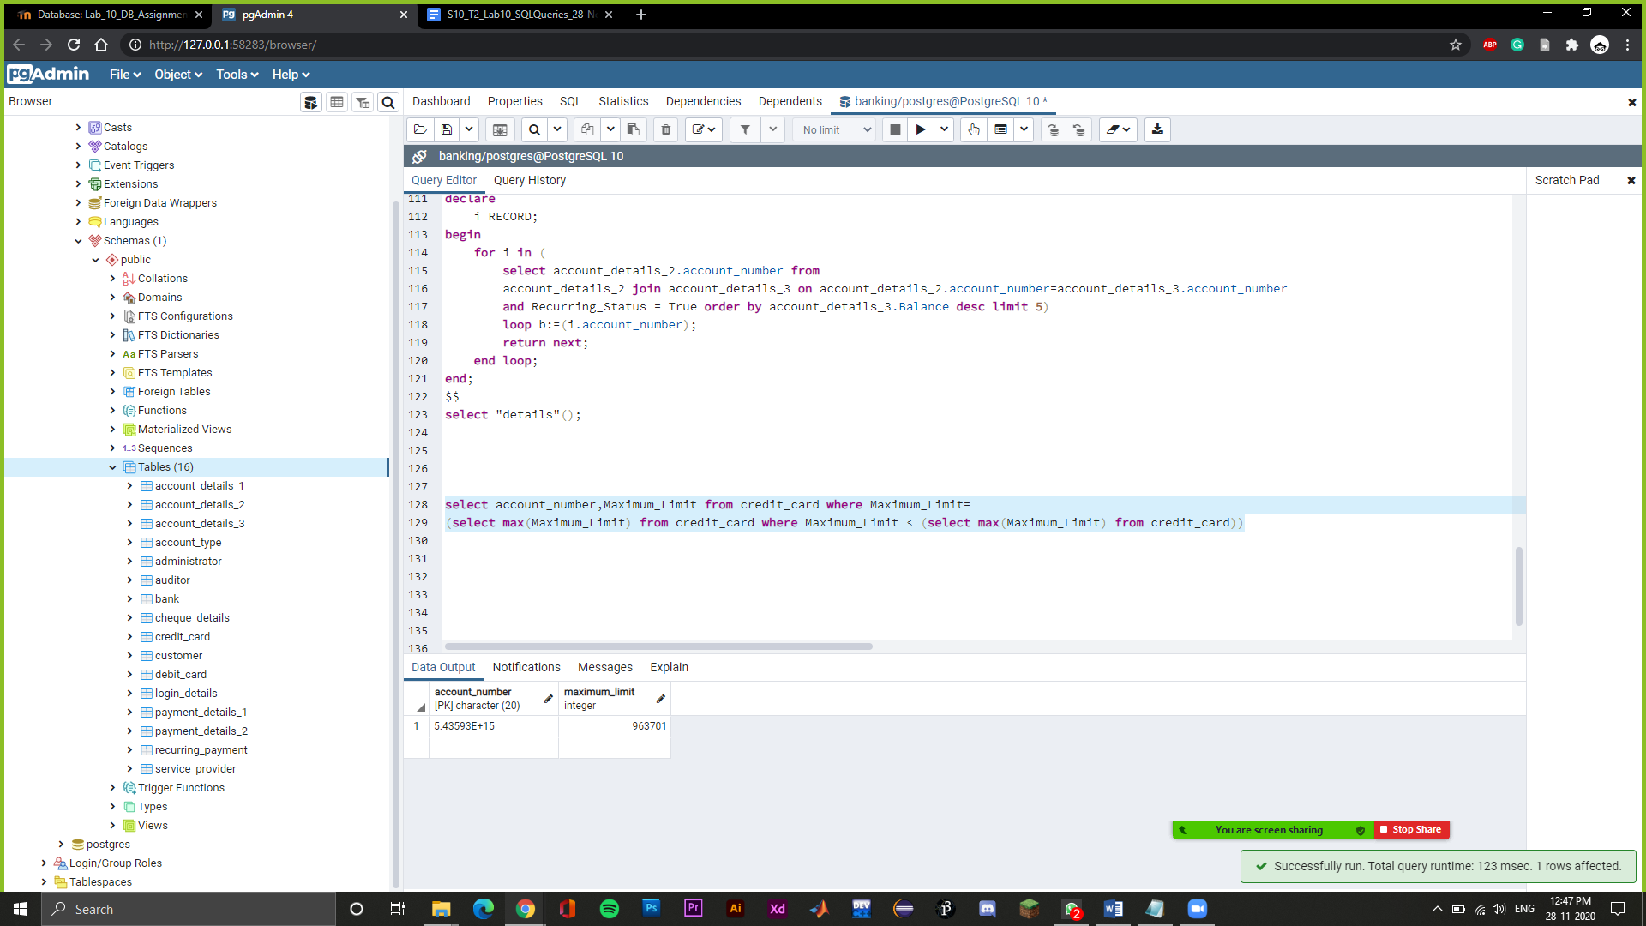

c**reate or replace function "details1"()**

**returns table(b character varying(250),number character varying(250),number1 character varying(250),number3 character varying(250))**

**language 'plpgsql'**

**as $$**

**declare**

**i RECORD;**

**begin**

**for i in (select customer_id,account_number,administrator_id,bank_name from account_type where auditor_id='81224')**

**loop b:=(i.customer_id);number:=(i.account_number);number1:=(i.administrator_id);number3:=(i.bank_name);**

**return next;**

**end loop;**

**end;**

**$$**

**select "details1"();**

->Create a function to display customer ID, account number, administrator ID and bank Name from account_type when the auditor ID is ‘81224’

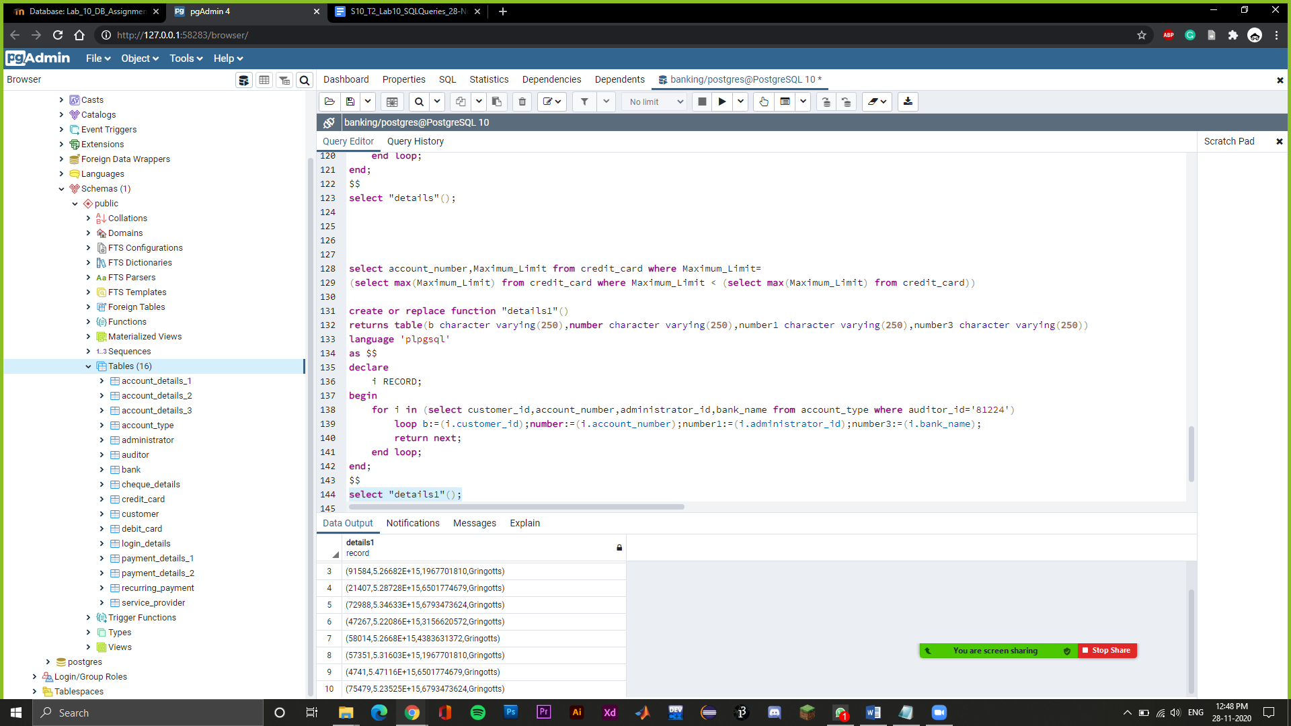

**create or replace function "details4"()**

**returns table(b character varying(250),number character varying(250))**

**language 'plpgsql'**

**as $$**

**declare**

**i RECORD;**

**begin**

**for i in (SELECT customer_id FROM account_type EXCEPT SELECT account_number FROM account_details_3 WHERE balance between '1200' and '9000'**

**)**

**loop b:=(i.customer_id);**

**return next;**

**end loop;**

**end;**

**$$**

**select "details4"();**

->Create a stored procedure of customer IDs except those who have their account balance between 1200 and 9000.

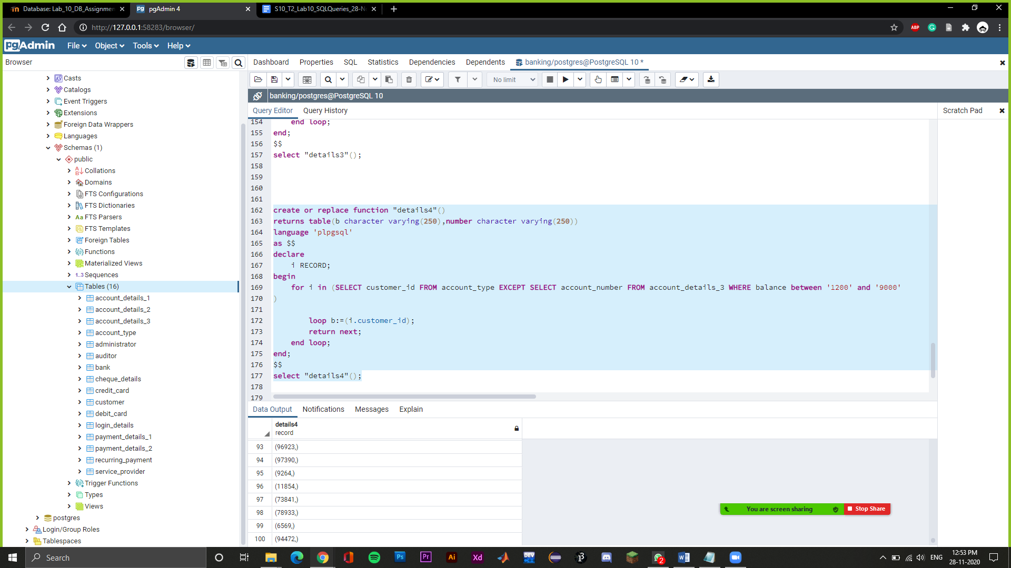

**create or replace function func_1()**

**returns trigger**

**language 'plpgsql'**

**as $$**

**begin**

**if (new.bank_name is NULL)**

**then UPDATE administrator SET bank_name = 'Gringotts' WHERE administrator_id = new.administrator_id;**

**raise notice 'Updated to default bank!';**

**end if;**

**return new;**

**end**

**$$;**

**create trigger "def_bank"**

**after insert on administrator**

**for each row execute procedure func_1();**

**INSERT INTO administrator(Audit_Details,Auditor_ID,Administrator_ID,Administrator_Name)**

**VALUES (18,52934,9240093889,'Arka');**

-> Insert the default name via after insert trigger if we don’t add the bank name for a new administrator

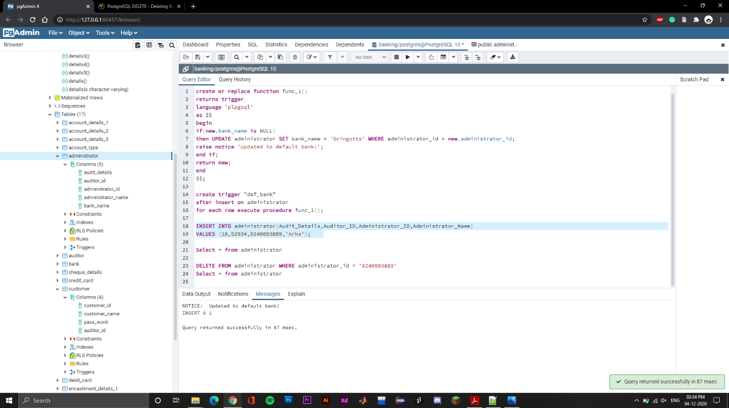

**Select * from administrator**

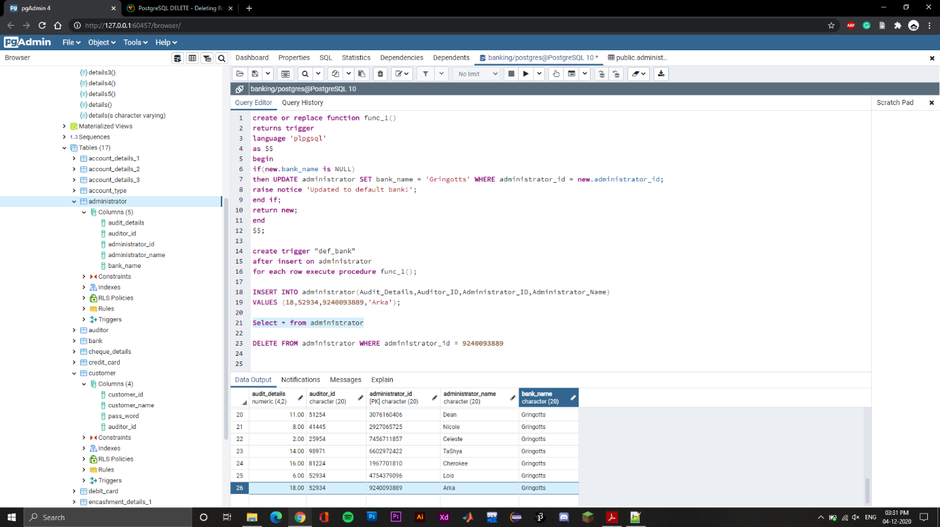

**create or replace function func_3()**

**returns trigger**

**language 'plpgsql'**

**as $$**

**begin**

**if(new.balance < 100)**

**then raise notice 'Balance must be in 3 digits';**

**return old;**

**end if;**

**return new;**

**end**

**$$;**

**create trigger "bal"**

**before insert on account_details_3**

**for each row execute procedure func_3();**

**INSERT INTO account_details_3(Account_Number,Balance,Recurring_Status)**

**VALUES ('5.43999E+15', 74, false);**

->If balance before insert is in 2 digits then raise minimum balance notice